Geometry: Unit 9, Lesson 4
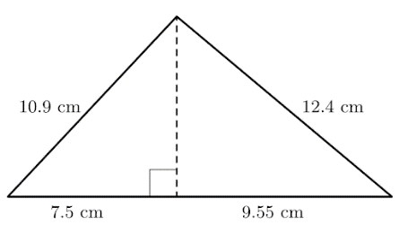
- What is the altitude of the triangle? Round to the nearest tenth of a centimeter.

$$7.9 cm$$

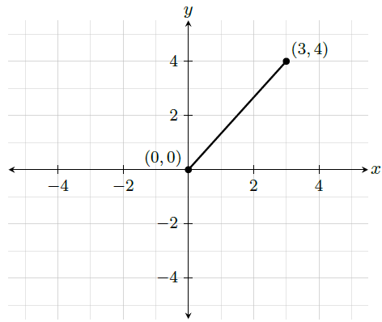
- Tommy wants to rotate the line displayed in the grid shown $90°$ counterclockwise with the origin as the center of rotation. What is the new location of the point at $(3, 4)$ after the rotation?

$$(-4, 3)$$
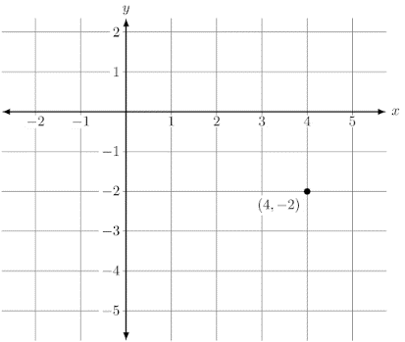
- The point $(4, -2)$ is shown on the coordinate grid. What are all the possible coordinates of the image after a $90°$ rotation about the origin?

$(-2, -4)$ and $(2, 4)$

